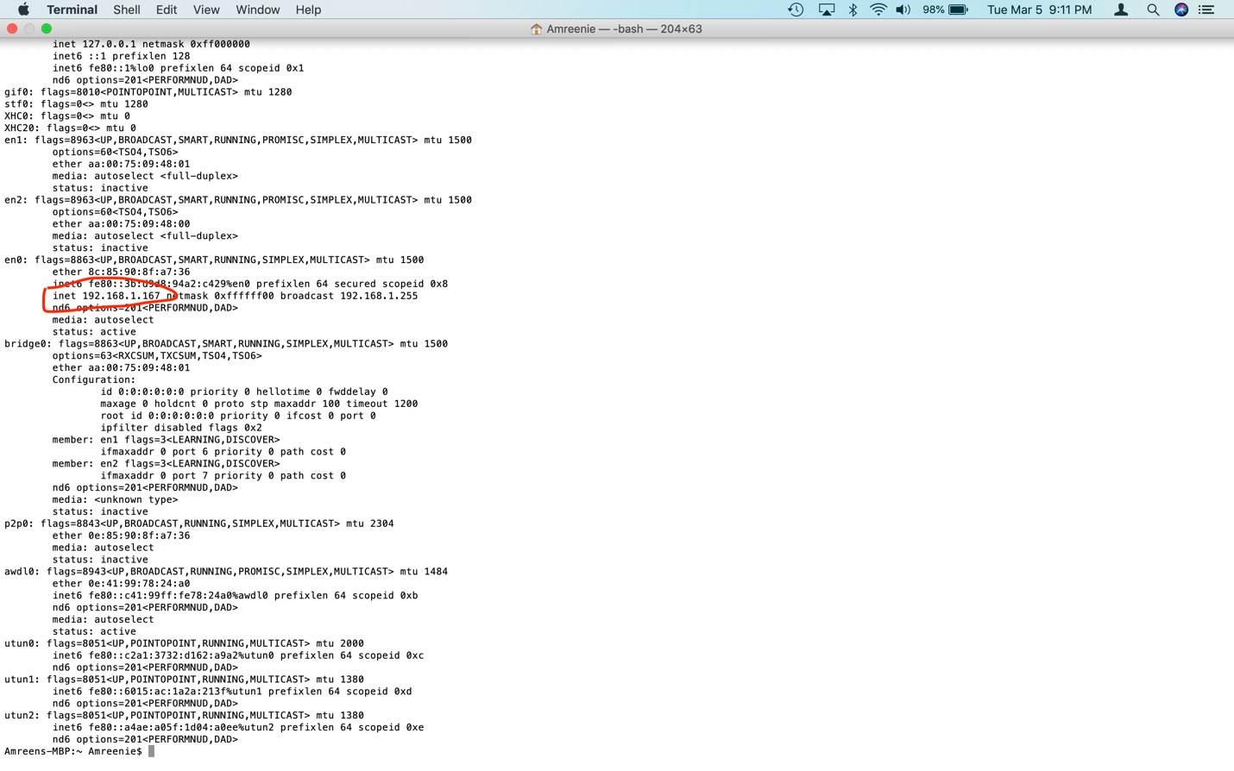

1. What is the IP address of your computer? – **Wireshark screenshot not Terminal**

192.168.1.167

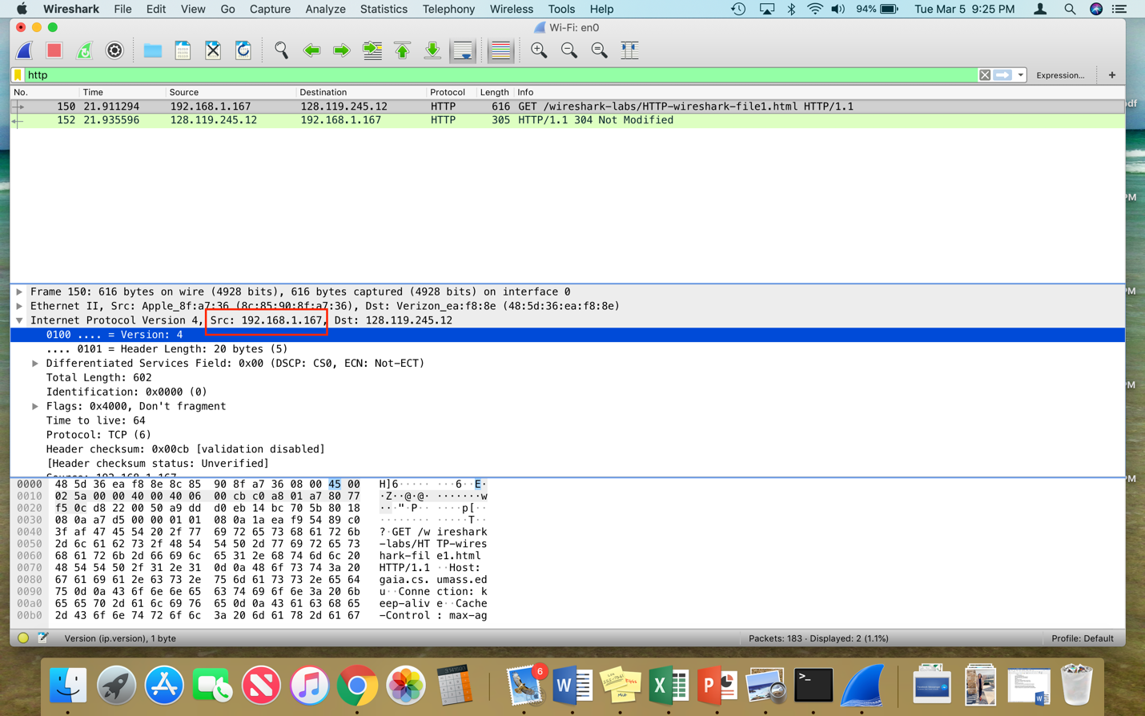

2. What is the total length of the datagram? 616 bytes (used the same screenshot for both, disregard the second red box)



3. Has this IP datagram been fragmented? No.

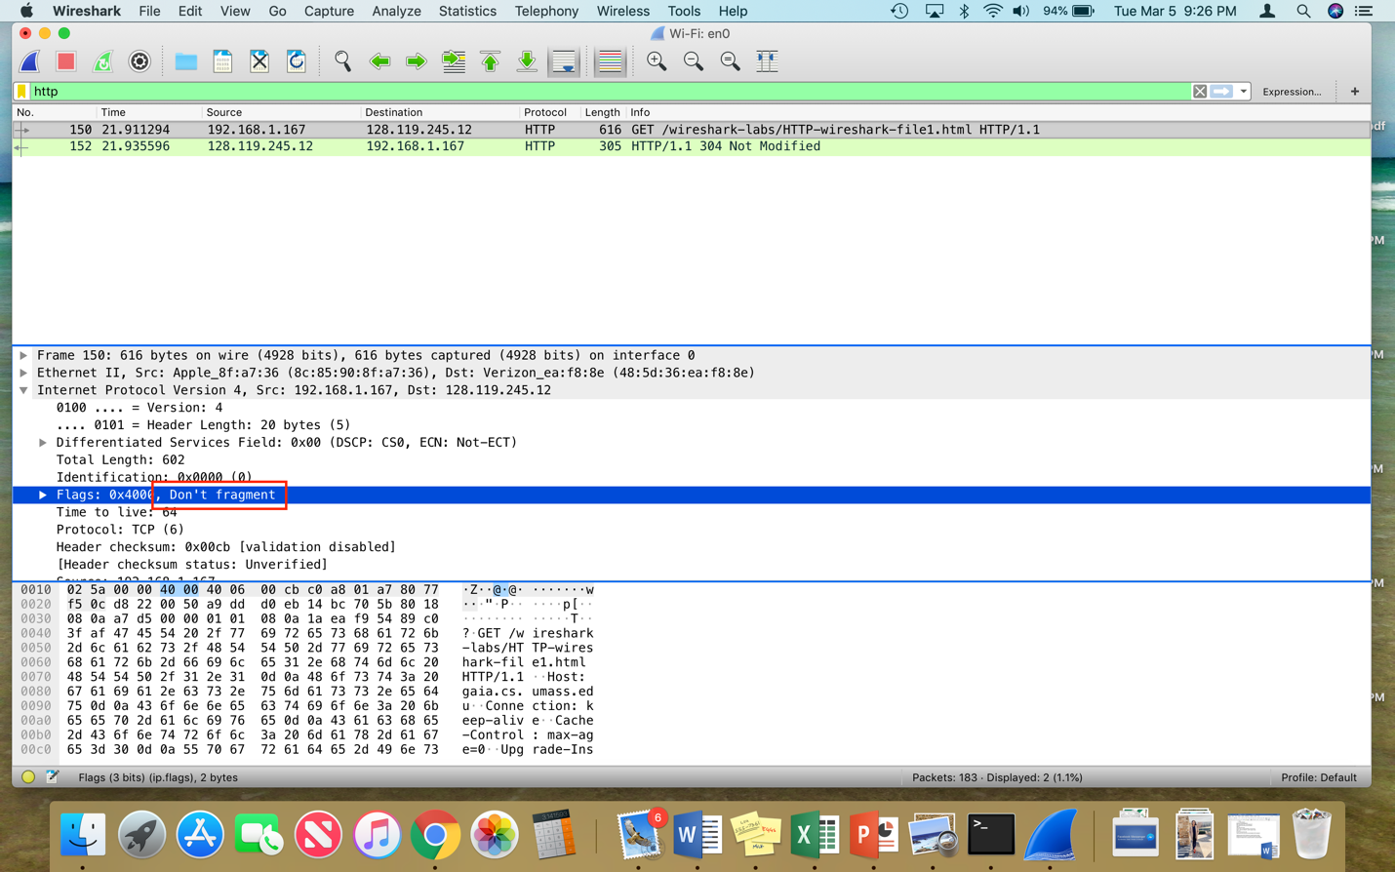

4. How many bytes are in the IP header? The header is 20 bytes

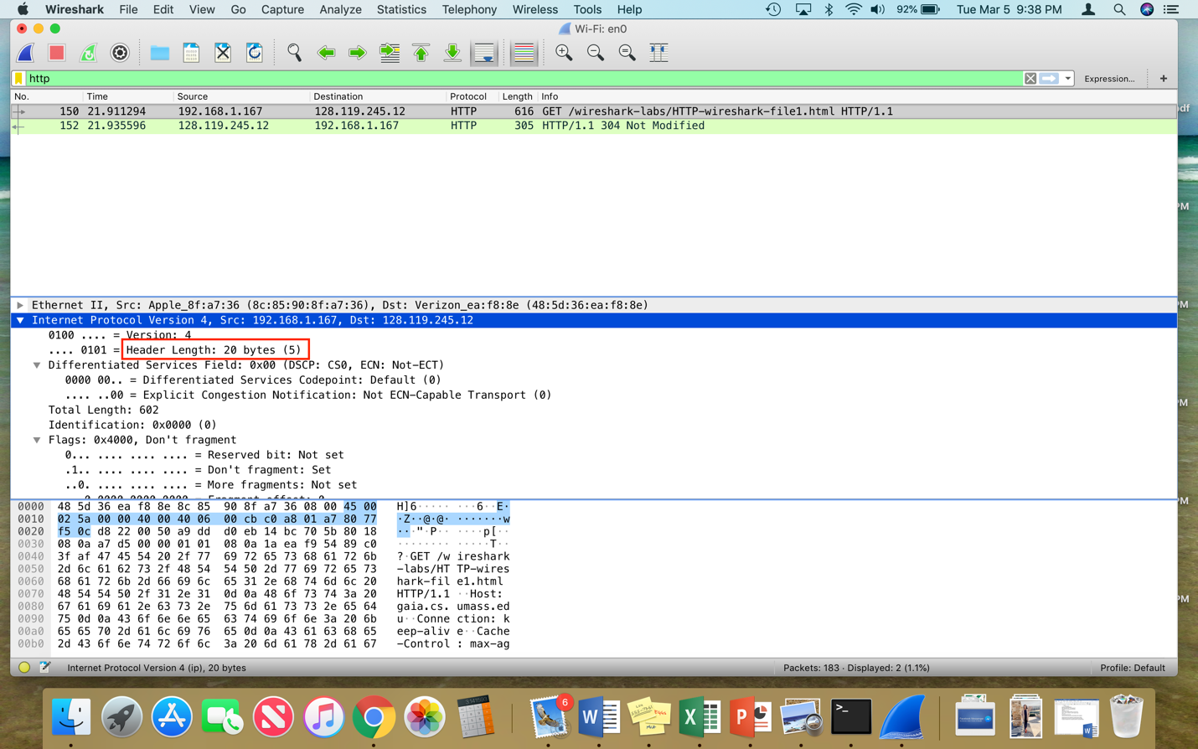

5. How many bytes are in the payload of the IP datagram? Explain how you determined the number of payload bytes.

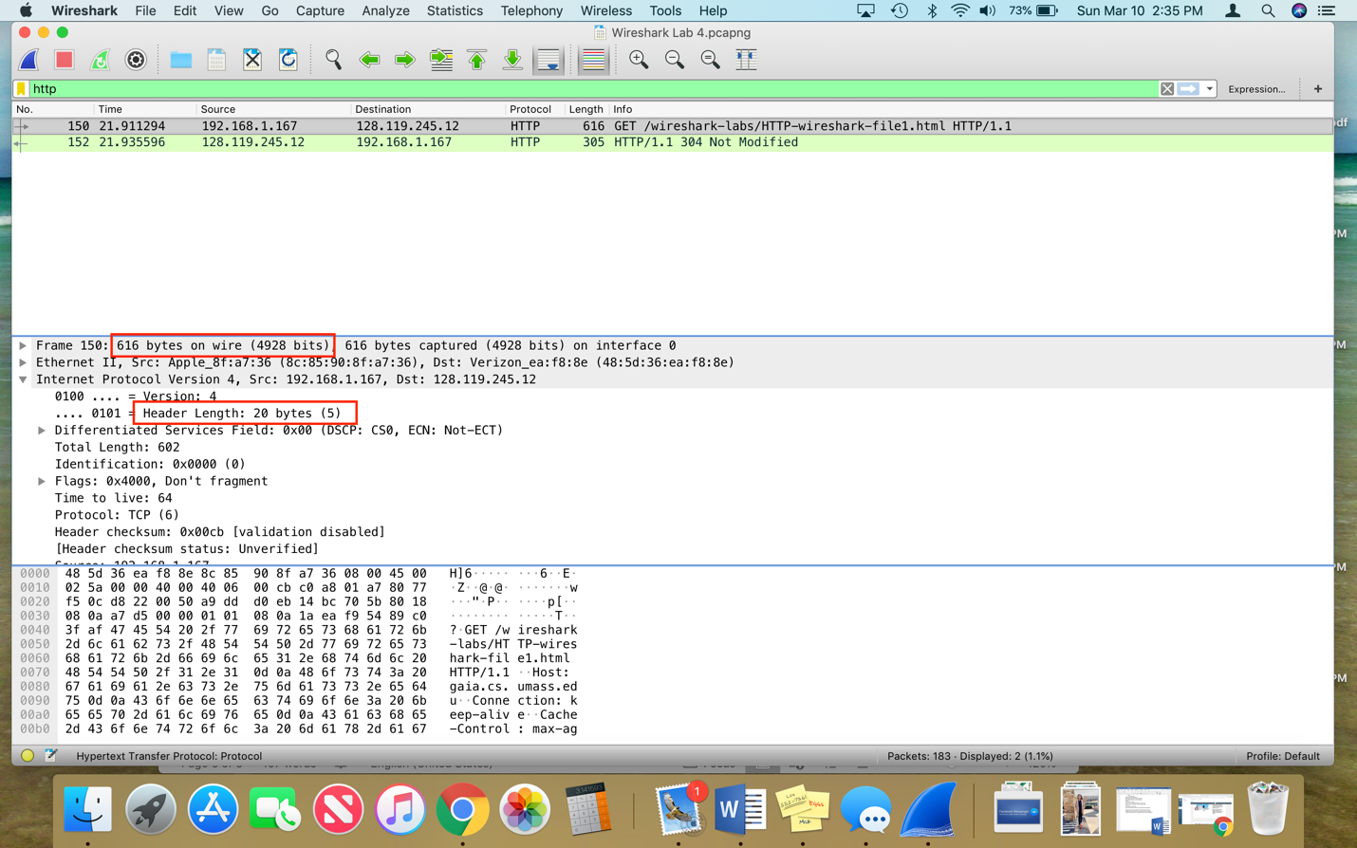The total number of bytes in the IP datagram is 596. You take the total amount of bytes – 616 – minus the bytes in the IP header – 20 bytes.